Step1:



1. What version of HTTP is the server running?

HTTP/1.1

2. How is the beginning of the content sent by the server recognized by the client?

HTTP/1.1 200 OK

3. How does the client know what type of content is returned?

Content-Type: text/html

Step3:

1. What is the format of a header line? Give a simple description that fits the headers you see.

Header is a key:value pair, the key is some descriptions that the server and client both know, the value is the value of corresponding key that describes the content of current key.

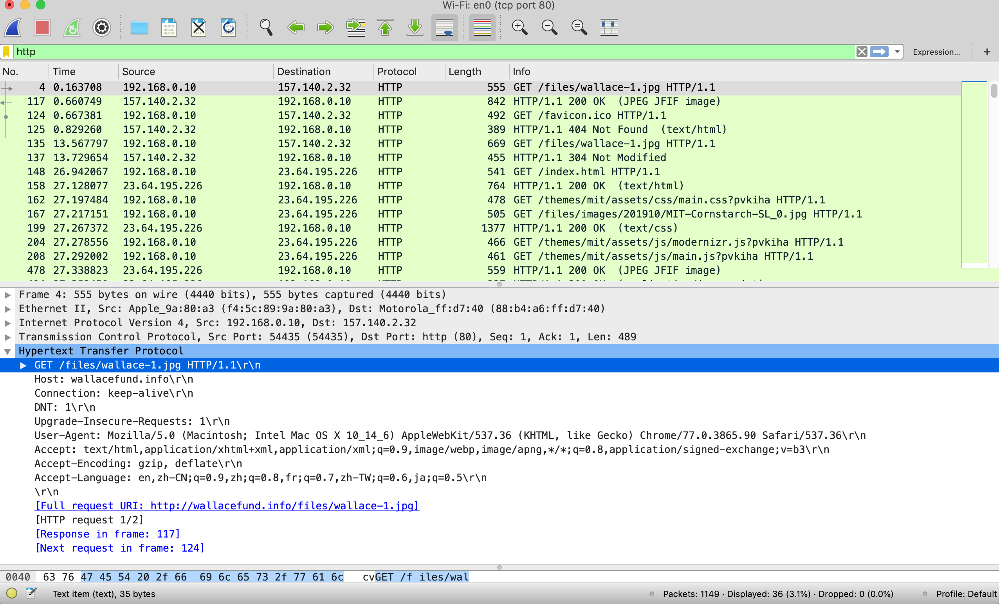

﻿Host: wallacefund.info\r\n

The **Host** request header specifies the domain name of the server (for virtual hosting), and (optionally) the TCP port number on which the server is listening.

﻿Connection: keep-alive\r\n

The Connection general header controls whether or not the network connection stays open after the current transaction finishes. If the value sent is keep-alive, the connection is persistent and not closed, allowing for subsequent requests to the same server to be done.

﻿DNT: 1\r\n

The DNT (**D**o **N**ot **T**rack) request header indicates the user's tracking preference. It lets users indicate whether they would prefer privacy rather than personalized content.

﻿Upgrade-Insecure-Requests: 1\r\n

The HTTP Upgrade-Insecure-Requests request header sends a signal to the server expressing the client’s preference for an encrypted and authenticated response.

﻿User-Agent: Mozilla/5.0 (Macintosh; Intel Mac OS X 10_14_6) AppleWebKit/537.36 (KHTML, like Gecko) Chrome/77.0.3865.90 Safari/537.36\r\n

The User-Agent request header contains a characteristic string that allows the network protocol peers to identify the application type, operating system, software vendor or software version of the requesting software user agent.

﻿Accept: text/html,application/xhtml+xml,application/xml;q=0.9,image/webp,image/apng,*/*;q=0.8,application/signed-exchange;v=b3\r\n

The Accept request HTTP header advertises which content types, expressed as [MIME types](https://developer.mozilla.org/en-US/docs/Web/HTTP/Basics_of_HTTP/MIME_types), the client is able to understand.

﻿Accept-Encoding: gzip, deflate\r\n

The Accept-Encoding request HTTP header advertises which content encoding, usually a compression algorithm, the client is able to understand.

﻿Accept-Language: en,zh-CN;q=0.9,zh;q=0.8,fr;q=0.7,zh-TW;q=0.6,ja;q=0.5\r\n

The Accept-Language request HTTP header advertises which languages the client is able to understand, and which locale variant is preferred.

2. What headers are used to indicate the kind and length of content that is returned in a response?

Indicate kind by Content-Type header.

Indicate length of content by Content-Length header.

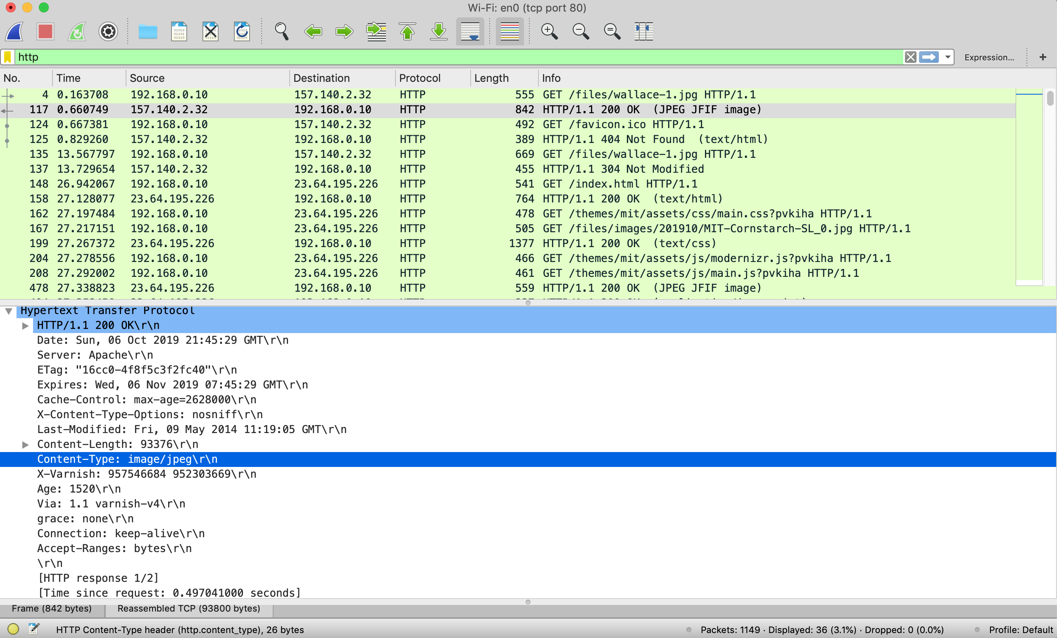

Step4:

1. What is the name of the header the browser sends to let the server work out whether to send fresh content?

If -None-Match and If-Modified-Since:

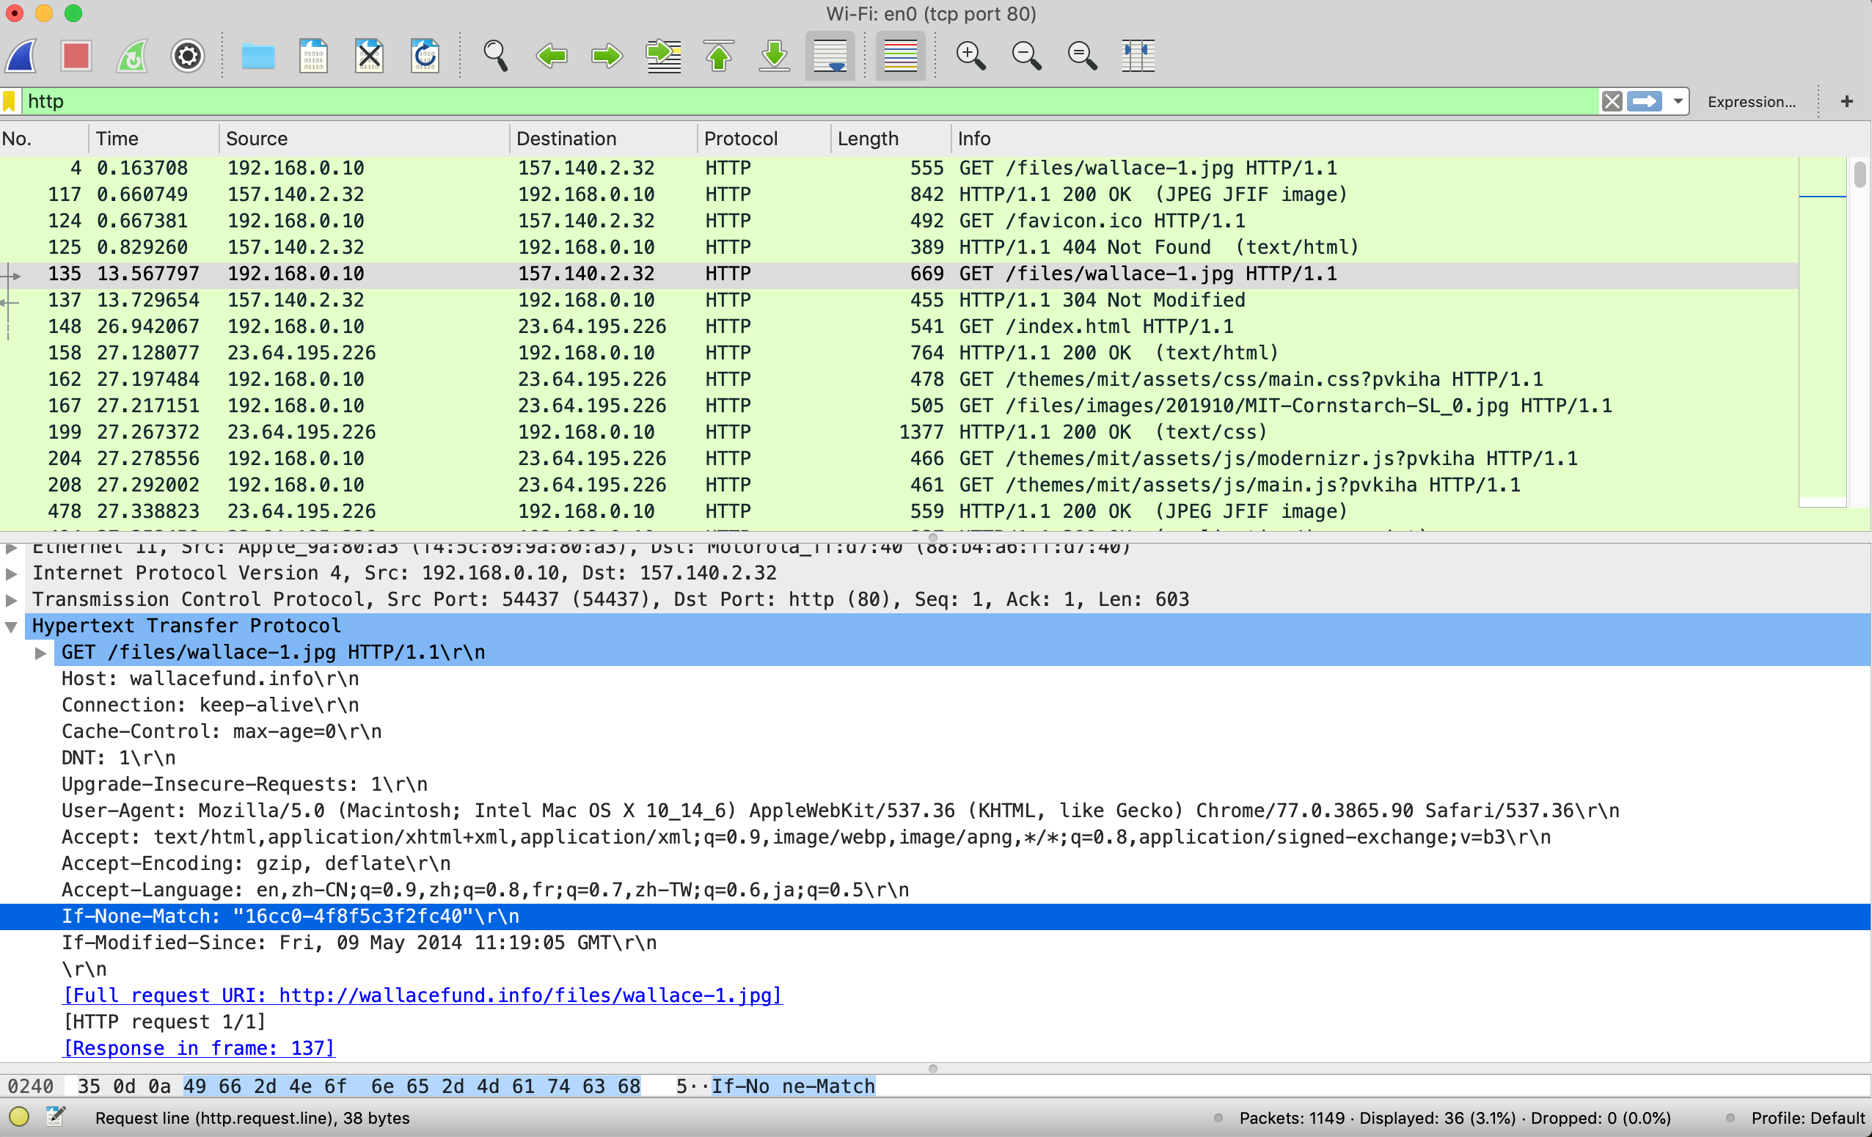

2. Where exactly does the timestamp value carried by the header come from?

From last 200 OK response of same request:

